SIT737- Cloud Native Application Development

Creating a Kubernetes Cluster for a containerized application

App.js

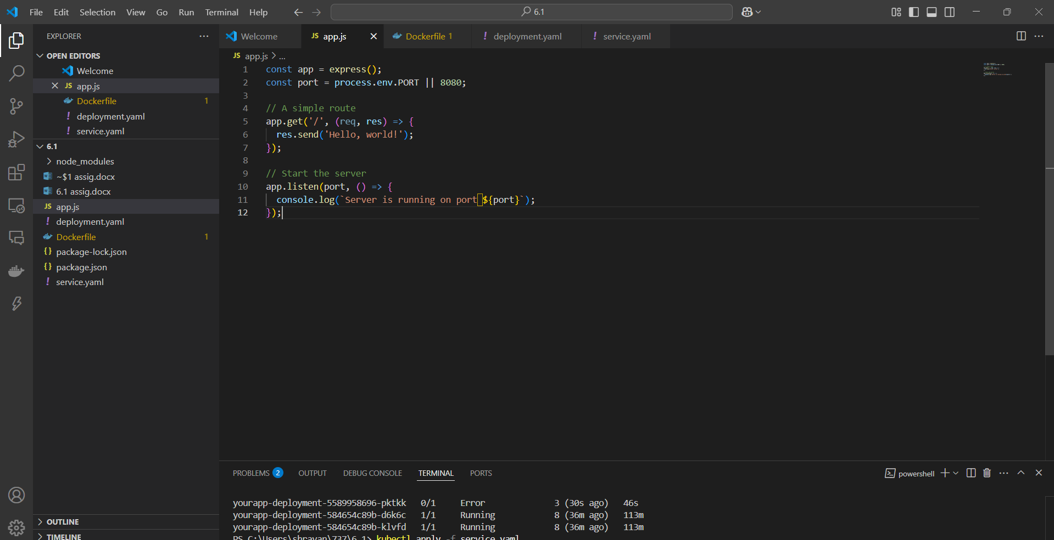

Dockerfile

Deployment.yaml

Service.yaml

Docker build

Docker image

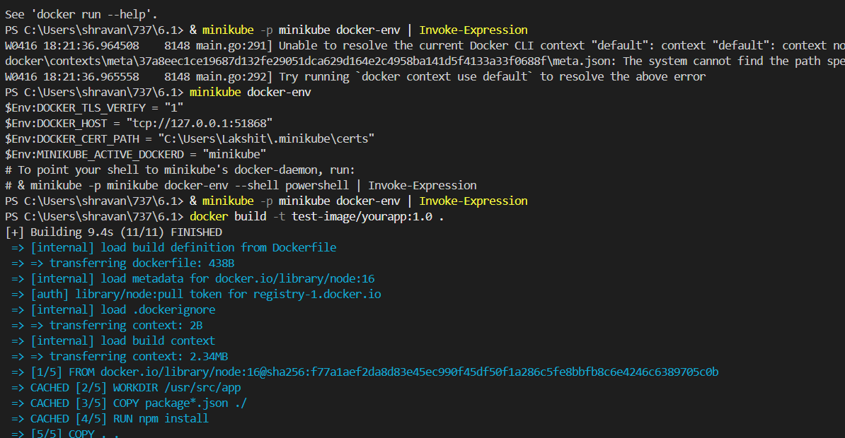

Kubectl apply deployments

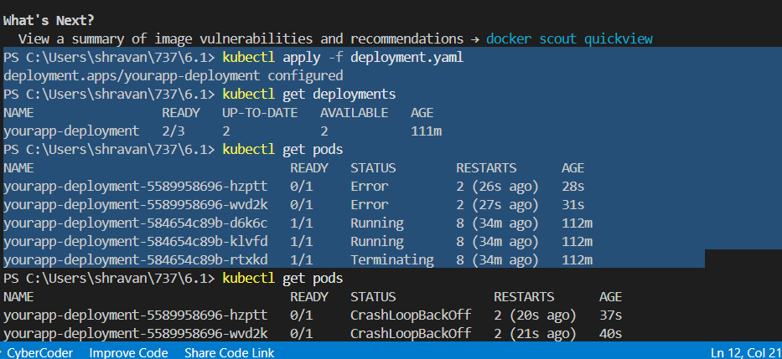

Hosting the image in local host

